Cambo First School
Behaviour Policy
Reviewed Jan 2023
Legal Framework
This policy has due regard to all relevant legislation and statutory guidance including, but not limited to, the following:

- Education Act 1996
- Education Act 2002
- Equality Act 2010
- Education and Inspections Act 2006
- Health Act 2006
- The School Information (England) Regulations 2008
- DfE (2016) ‘Behaviour and discipline in schools’
- DfE (2018) ‘Sexual violence and sexual harassment between children in schools and colleges’
- DfE (2018) ‘Mental health and behaviour in schools’
- DfE (2015) ‘Special educational needs and disability code of practice: 0 to 25 years’
- DfE (2013) ‘Use of reasonable force’
- Voyeurism (Offences) Act 2019
- Restrain Reduction Network [RRN Training Standards] July 21
- KCSIE 23
- DfE [2023] ‘Suspension and Permanent Exclusion form maintained schools, academies and pupil referral units in England, including pupil movement
This policy operates in conjunction with the following school policies:
- Pupil Code of Conduct
- Anti-Bullying Policy
- Social, Emotional and Mental Health (SEMH) Policy
- Special Educational Needs and Disabilities (SEND) Policy
- Child Protection and Safeguarding Policy
- Child on Child abuse Policy
- Exclusion Policy
- Complaints Procedures Policy
- E-Safety Policy
- Acceptable Use Policy
- Camera and Video Policy
- Mobile phone policy,
- ICT Policy
Introduction Our aim is to provide a happy, purposeful, environment, in which every child can
feel secure and so flourish, reaching his/her full potential and to value parents and carers as ‘partners’ in the learning process.
At Cambo we believe that helping children develop attitudes that will enable them to become kind, responsible, hardworking citizens is our most far-reaching role. We create overt opportunities for development of their self esteem and work with parents to ensure children grow up with a positive sense of self worth, aware of their rights and responsibilities in a community. We make every effort to ensure that adjustments are made to the policy and its application when and where necessary.
At Cambo we also understand that some children find it difficult to meet our behaviour expectations e.g. they can be beyond their developmental level. In these instances, children will have a bespoke positive behaviour plan which may additionally include rewards to reinforce positive behaviour.
The Governing Body has the responsibility of setting down guidelines on standards of
behaviour and reviewing their effectiveness.

The head teacher has the day-to-day authority to implement the Behaviour for Learning
Policy.

Teachers and Support Staff in school are expected to accept responsibility for
maintaining good behaviour throughout the school. They should have high expectations
of the children in terms of behaviour; and support all children to work to the best of their
ability. They should reinforce good behaviour through positive encouragement and praise
treat all children fairly with respect and understanding. If a pattern of behaviour emerges
the school will consult with outside agencies such as Educational Psychologists, Education
Welfare Officers or the SEND team, as needed.

At Cambo we work in partnership with parents/carers on all aspects of a child’s
education including their behaviour. We know that good liaison takes time and requires
resources. We are active in establishing links and forging positive relationships. We have
regular parental meetings and information sessions. We advertise our policies on the website to ensure that harder to reach parents are kept informed. Parents are made aware of the school rules which are re-negotiated with children annually.

Behaviour outside the school gate
Teachers have a statutory power to discipline pupils for misbehaving outside the school
premises. They may discipline a child for any misbehaviour when the child is taking part in
any school organised, or school related event; travelling to or from school, wearing school
uniform or in some other way identifiable as a child at the school.
General Principles
- To create a culture of very good behaviour, for learning, for our community and for life in general.
- Everyone working in or visiting the school premises is expected to behave in a respectful manner towards others and take care of the contents and fabric of the building.
- Both adults and children have the right to be addressed by their given name at all times.
- Both adults and children have the right to be treated with respect at all times. There is an expectation of cooperation, fairness and honesty which clearly demonstrates respect and provides a sound basis for the growth of self esteem.
- Misbehaviour is taken as a sign of emotional, social, medical or academic difficulties and every effort is made to listen, talk through and resolve problems.
- We support children in taking control over their behaviour and being responsible for the consequences incurred.
- Through establishing a clear set of guidelines children know how to behave well, are supported in achieving this successfully, and develop a positive self image. They develop strong attitudes that equip them to become kind, responsible, hard working citizens.
- To build a community which values kindness, care, good humour, good temper, obedience and empathy.
Teaching of good behaviour
Understanding how to behave has to be taught to our young children. Good behaviour is
modelled by adults in their interactions with children and each other. We recognise that
children learn respect by receiving it. As a school we:-

- Ensure that all staff understand and use consistently positive behaviour management strategies.
- Ensure that all staff joining the school (including supply teachers) are given clear
guidance and use the school’s systems.
- Use SEAL/JIGSAW/PHSE Association/NOS materials, Circle Time, PHSE sessions and Worship times to develop children’ emotional literacy.
- Agree with staff how they will teach children to manage strong feelings, resolve conflict, work and play cooperatively and be respectful and considerate.
- At the beginning of each academic year children create their own school rules
with support from teaching staff: ~The importance and relevance of these rules in
various situations are discussed and children understand that these rules form the
expected code of conduct in school and are principles that will help them achieve
success wherever they are. All of the children sign the rules to say that they will
abide by them.
- The Home-School agreement is read and signed by children, parents and teacher
when a child starts school.
- Arrange additional small group support for children who need it.
- Arrange for 1-1 support when needed.
- Monitor the effectiveness of behaviour management through observations by head teacher and School Improvement Partner and Governors

Rewarding good behaviour
Cambo First School recognises that the use of praise in developing a positive atmosphere in the classroom cannot be underestimated, A quiet word of personal praise can be as effective as a larger, more public reward. It is the key to developing positive relationship including those with children who are the hardest to reach.

Good behaviour is an expectation for all and is also rewarded in a number of ways:

- For outstanding examples of achievement in academic or social areas “stickers
and marbles” Success is celebrated in class and assemblies. This public recognition
of success is important for all children to experience.
- Verbal praise and congratulation to children often and in a way that meets the needs of the individual.
- Reward stickers given out by staff to acknowledge effort, excellent work or
Behaviour
- Children’s names are entered into the ‘Proud Cloud’ with rewards
- Child encouraged to show other staff good work at the end of a lesson.
- Work and good behaviour shared with head teacher for praise and a sticker.
- Marbles are earned for good behaviour and full jars are turned into whole school rewards.
- Star of the Week – certificate and recognition in Community Assemblies on Fridays.
- Community assemblies are used to praise children e.g. effort, good behaviour, attainment.

Home/School
Liaison between parents and teachers is valued and parents are welcomed into school in
order to build good home/school relationships. Parents are kept closely informed about
their child’s progress and are expected to fully support the school’s behaviour policy. A
collaborative approach to a child’s behaviour /difficulties is always sought.

Adults are expected to set a good example to children by showing courtesy towards
each other and towards children.

Children are expected to wear school uniform, encouraging a sense of unity and pride in
belonging to the school community.

Children who are deemed to be ‘vulnerable’ will be assigned a ‘key person’ in school
who knows them well. This key person will have good links with the home and will act as a
reference point for staff when they are unsure about how to apply the disciplinary
framework.

Classroom management, learning and teaching
We have an interesting, creative and appropriate curriculum, accessible to children of all
abilities. This is supported by high quality assessment and helps children to be engaged in their learning. As a school we:

- Plan lessons well, using strategies appropriate to the ability of the children.
- Give children the opportunity to take responsibility for aspects of their learning, working in pairs, groups, as a class and as a whole school.
- Use Assessment for learning techniques, such as peer and self-assessment, to increase children’s ‘involvement in their learning and promote good behaviour.
- Use our knowledge of children to plan grouping and target support on areas where children have the greatest difficulty.
- Operate a classroom seating plan, so that social interactions do not inhibit learning and create behaviour problems.
- Build into lessons opportunities to receive feedback from children on their progress and their future learning needs.
- Give opportunities for class and school council to discuss their knowledge and their school experience, their understanding of bullying and the effectiveness of rewards and sanctions.

Management of Behaviour
Although good behaviour and a cooperative attitude are expected from all children at all times, consequences are sometimes needed to reinforce the School Rules when
behaviour is not acceptable. These include:

Ignoring the child misbehaving and giving praise and attention to another child who is
behaving well. At the first opportunity divert the misbehaving child’s attention from what
he/she is doing and give him/her something to do that they can easily achieve and be
praised for. (e.g. Give them a job to do.)

If negative behaviour reoccurs take the child aside to privately reprimand, reminding
of which school rule has been broken and the consequences of that. Separating
the negative behaviour from the child, showing them how to put things right and
re-establishing good relationships will provide a supported opportunity for self-correction.
Three warnings will be given.
“Time out” to be taken in another room/feelings area, for cooling down and reflection with adult support.
Entry into the school behaviour book. If the warnings go unheeded then the child will be
taken to the head teacher, where in partnership the child will talk with the head teacher
to try and resolve the behaviour issue. The behaviour issue will be written into the
behaviour book. The child will be instrumental in dictating what the poor behaviour was.

Devising a plan of action for moving forward and sanctions associated. If the child’s
name goes into the behaviour book 3 times in half a term then the child’s parents will be
asked into school for a meeting to discuss their child etc. The converse is also true e.g. if
the child does not exhibit the poor behaviour again in that half term a tick is placed in the
behaviour book to denote that the poor behaviour has not been repeated and the child
has a fresh start.

If a pattern of negative or inappropriate behaviour occurs a “Behaviour Diary” may be
issued to the child. This enables the teach/head teacher to monitor behaviour, reward
good behaviour with praise and encouragement, At the end of a three-week period
positive behaviour should be evident and child self-esteem strengthened. The child
continues to receive on-going support from the teacher/head teacher and/or other adults in school including parents
Other Methods At the beginning of each academic year children create their own school rules with support from teaching staff:~The importance and relevance of these rules in various situations is discussed and children understand that these rules form the expected code of conduct in school and are principles that will help them achieve success wherever they are. All of the children sign the rules to say that they will abide by them.
The Home-School agreement is read and signed by the child, parents and teacher when a child starts school.
All positive behaviour is encouraged and rewarded. For outstanding examples of achievement in academic or social areas “stickers and marbles” Success is celebrated in class and assemblies. This public recognition of success is important for all children to experience.
Liaison between parents and teachers is valued and parents are welcomed into school in order to build good home/school relationships. Parents are kept closely informed about their child’s progress and are expected to fully support the school’s behaviour policy. A collaborative approach to a child’s behaviour /difficulties is always sought.
Adults are expected to set a good example to children by showing courtesy towards each other and towards children.
Children are expected to wear school uniform, encouraging a sense of unity and pride in belonging to the school community.
Children who are deemed to be ‘vulnerable’ will be assigned a ‘key person’ in school who knows them well. This key person will have good links with the home and will act as a reference point for staff when they are unsure about how to apply the disciplinary framework.
If a serious incident has occurred the head teacher will inform parents and a special agreed behaviour plan/Risk assessment will be generated. Some children might require an agreed behaviour plan/Risk assessment on entry to school or at some time in their educational life at Cambo, this will be facilitated by the head teacher where necessary.
We believe that positive reinforcement is always the way forward. We praise good behaviour as we feel that every child needs to know and feel that they are valued within the school community. We are the ‘Family of Cambo’.
Removal from an activity/classroom Engagement with learning is always our primary aim at Cambo First School. For the vast majority of learners, a gentle reminder is all that is needed within school. However, we recognise that there may be occasions when removal is necessary for a short period of time. In these instances, steps should be gone through with care and consideration, taking an individual’s needs into consideration. It is important to praise the behaviour you want to see, and not pander to attention seeking.
All learners must be given the time for intervention to have a positive effect with reference to low level disruption. Teachers must also be aware of their expressions/body language when deescalating behaviours.

Redirection/Reminder
Gentle encouragement, a nudge in the right direction,
a reminder of the rules and expectations delivered privately where possible. With repeated reminders if necessary to deescalate behaviours.

Caution
A clear verbal warning delivered privately wherever possible with clear consequences should the behaviour continue. The learner has the choice to do the right thing.
Remind the child of previous good behaviour.
Stop, think and make the right choice.

Last Chance
Speak to the child privately, give them a final opportunity to engage.

I have noticed that… [shine the light on the behaviour]
Because of that you need to… [action to support behaviour]

See me for… 5 mins at break time …

Do you remember earlier, yesterday, last week when you... [refer to previous positive]

Cool off
Could be a short time out of class, at a different desk, calm space, this ensures that the child has the time to look at the situation from a different perspective and compose themselves.

Repairing and Restorative conversation…
What happened? what were you thinking at the time? What have you thought since? How did this make people feel? Who has been affected? How have they been affected? What should we do to put things right? How can we do things differently in the future?

Consequences
To be agreed with the child. This may involve other children impacted upon by child suggesting a consequence. However, if a child has three incidents in any one week requiring support. Then the teacher must inform parents. Children who regularly misbehave three times per week will have a weekly monitoring meeting with the head teacher/THRIVE practitioner during lunch time.

A serious breach may lead to a fixed term exclusion e.g. all forms of bullying, racist, sexist, or homophobic/transgender comments, inappropriate name calling, using abusive/offensive language, physically striking adults

Reasonable Force
The use of reasonable force may be required in specific situations. 6 members of school staff are
CPI [Crisis Prevention Institute Safety Intervention] trained and training is updated annually via Northumberland County Council. [January 2023]

Only those staff fully trained will exert any reasonable force, should this be required. Any physical intervention will be used as a last resort. Restrictive interventions will be reasonable, proportionate and least restrictive to maximise safety and minimise harm. These legal and professional considerations will be applied:

- Duty of care
- Best interests
- Reasonable and proportionate
- Last resort and least restrictive
- The risk of doing something and the risk of doing nothing
- Human rights

Cambo First School has a legal duty of care for all children. Where a child is creating a situation where they are threatening the well-being of others; reasonable force may need to be used to
control or restrain them. Reasonable force will only be used as a final option. Staff will always try to
intervene verbally before such use. Where staff fear for their own safety and the child is
not responding to a verbal request, help from the head teacher will be requested. The
teacher may decide to remove the whole class from the situation rather than use force to
remove the child depending on their own professional judgement.

On the playground a similar approach is adopted:

- Time out. Go and stand at the yard wall for 1 minute to think and calm down (can
be extended)
- Hold my hand. Calm down and talk to me. We can put this right. (2-3 minutes)
- Talk with an adult to reflect on the incident, understand what went wrong and work
out a plan to put it right.

If a pattern of inappropriate behaviour occurs a behaviour diary for the playground may
be issued or a plan developed with the THRIVE practitioner.

Mid-day supervisors regularly update the class teacher/head teacher with an overview of
general behaviour so that minor problems can be addressed. Our mid-day supervisors are fully CPI trained.
Physical Intervention In applying Physical Interventions, we abide by DFE guidelines set out in ‘Use of Reasonable Force-Advice and guidelines for headteachers, staff and governing bodies. [July 2013]
In school the responsibility for monitoring ‘Physical Intervention’ remains with the Head teacher.
Physical intervention by a member of staff may be necessary as a last resort in the following circumstances:~
- When a child is endangering his/her own safety or the safety of others.
- When a child’s behaviour is causing disruption and is encouraging other children to behave disruptively.
- When a child is causing significant damage to equipment or the building.
All staff at Cambo First School are CPI trained re methodology. 6 members of staff are fully trained re methodology/physical interventions. [2023/NCC] and a plan of review is in place to ensure skills/knowledge/understanding and accreditation are continued annually.Re accreditation January 2024. All incidents of Restrictive Physical Intervention must be recorded as quickly as possible and in any event within 24 hours of the incident following school procedures and forms.
The Headteacher or Senior teacher must be informed at the earliest opportunity. Parents/Guardians should also be contacted as soon as practicable. A written record must be created using agreed information e.g. name of staff, child involved, date, time duration re physical intervention, type of intervention used etc.
[Please refer to appendix 1]
No member of staff should be alone with a child in a restraining situation. A minimum of two adults should be involved to ensure the safety of all concerned, provide reliable witnesses and a carefully considered approach in a potentially emotionally charged situation.
Monitoring depends on good recording of incidents. The agreed paperwork must be completed and placed in the physical intervention file.
Exclusion
At Cambo First School it is recognised that using exclusions can add to the risk of abuse
and exploitation as children are not in school and can therefore be very vulnerable.
Exclusions, whether temporary or permanent, must be avoided at all costs. It is noted that
there have been no exclusions at Cambo.

If all avenues have been explored with a child, or an incident is of a serious nature and it
is felt that a temporary or permanent exclusion in necessary, then only the Headteacher
has the power to exclude a pupil from school. The Headteacher may exclude a childl for
one or more fixed periods, for up to 45 days in any one school year. The head teacher
may also exclude a child permanently. If the head teacher excludes a child, they must
inform the parents immediately, giving the reasons for the exclusion. At the same time, the
Headteacher makes it clear to the parents that they can, if they wish, appeal against the
decision by contacting the Governing Body. The school informs the parents of how to
make such an appeal. If the Governing Body’s Appeal Panel decides that a child should
be re-instated, the headteacher must comply with this ruling. The Headteacher informs
the Local Authority and the Governing Body about any permanent exclusion and about
any fixed term exclusions beyond five days in any one term.

The Governing Body itself cannot either exclude a child or extend the exclusion period
made by the head teacher.
Bullying/cyber bullying and Racial harassment Bullying/cyberbullying and racial harassment will not be tolerated at any level. Any instances of either are reported as soon as possible to the head teacher. A record of both is kept and parents are informed to ensure a collaborative and effective resolution of the problem. [refer to Equalities Policy, Anti-bullying policy, Safeguarding Policy, E-Safety Policy, Acceptable Use Policy, Camera and Video Policy, Mobile phone policy, ICT Policy ]
Monitoring Any child giving cause for concern is brought to the attention of all staff generally and at staff meetings. Appropriate strategies are then discussed and a course of action planned. A referral to the School Support Team or other outside agencies may be made if appropriate.
Evaluation This will be carried out by the head teacher who will monitor the number of children who are asked to complete behaviour records/interventions as well as the standard of behaviour in general around the school.
The head teacher is responsible for supporting staff, ensuring they are all aware of the school’s behaviour policy and providing training when needed.
This policy will be reviewed annually. *Please refer to all other school policies in conjunction with this policy
Signed: Paula Cummings [head teacher] Ratified by Governing Body March 23
This policy will be reviewed January 25

Appendix 1
Cambo First School
Recording and Reporting

All incidents of Restrictive Physical Intervention must be recorded as quickly as possible and in any event within 24 hours of the incident in a way acceptable to the regulatory authority.
The Headteacher or a person acting on his or her behalf must be informed at the earliest opportunity. Parents/Guardians should also be contacted as soon as practicable.
As a minimum the written record should include:

- The names of the staff and children or young people involved.
- The date, time and duration of the intervention.
- The reason for using a physical intervention, rather than using an alternative
- Strategy.
- The nature of any de-escalation used seeking to prevent the need to
- intervene physically.
- The type of physical intervention used.
- Whether or not anyone was hurt, if so the action taken.
- Whether or not anyone was distressed, if so the action taken.
- The views of the child or young person.
- Recording Restrictive Physical Interventions serves several purposes, including:
- Compliance with statutory requirements.
- Monitoring the welfare of children and young people.
- Monitoring staff performance.
- Identifying training needs.
- Contributing to service audits and evaluations.
- Details of how and when the incident was reported to parents / carers.
- Following up and de-briefing. Incident Report Book
Incident Reporting
As soon as possible after the incident the member of staff should be de-briefed by an appropriate senior member of staff. In our school this will be the Headteacher or Senior Teacher. The de-brief will allow for reflection and the relevant Senior member of staff should be prepared to deal with the emotions raised by the incident. The de-brief enables learning to take place and contributes towards professional development.

The response of the child or young person should be sought and he or she should also be allowed to reflect on the incident. The risk assessment should be reviewed.
Monitoring
Monitoring depends on good recording of incidents of Restrictive Physical intervention, the agreed paper work must be completed and placed in the physical intervention file. Senior managers will monitor episodes of Restrictive Physical Intervention both individually and by school. However narrative records will always be important for monitoring practice.

In schools, responsibility for monitoring the use of Restrictive Physical Interventions lies with the Head Teacher provides an overview report annually of the incidence and management of RPI in the school to the Governing Body. In turn, the Governing Body, should also be aware of its duties to safeguard children and young people and should pay due regard to the Local Safeguarding Children Board’s policies and procedures.

Monitoring serves two purposes. At the individual level it allows for improved practice with the individual young person, whilst at the strategic level it has the potential to influence policy and practice. Incident Report Book

Appendix 2 Behaviour Crisis Recording Form CPI Safety Intervention form
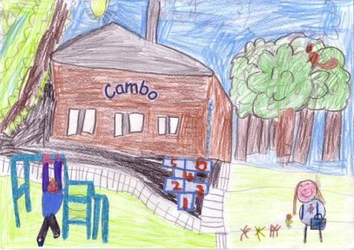

Cambo First School

Date: | Time: | Duration of Incident:
Name of Pupil: | Staff Involved: | Location of Incident:
Trigger(s) observed (where applicable):

Risk Behaviour(s) observed:

Staff Response(s):

Brief description of Incident:

CPI Disengagement(s) used: Y / N Type:

Level: L M H
CPI Hold(s) used: Y / N
(circle where appropriate)

Type: Seated Level: Low Medium High
Duration (minutes): . . .

Standing Level: Low Medium High
Duration (minutes): . . .
Tension Reduction behaviour(s) observed:

Staff Response(s):

Signed (Author): Other Staff: _______________

Copy given to Headteacher: Y / N Signed (Headteacher): Paula Cummings
Parents Informed of Incident: Y / N
NCC Incident Form Completed: Y / N

Appendix 3 - Restorative Practice at Cambo First School
Definition
The aim of restorative practices is to develop community and to manage conflict and tensions by repairing harm and building relationships.
Restorative Practices in Schools is about:
• building safer schools
• changing behaviour not punishing
• adults modelling restorative approaches
• finding ways to repair harm
• supporting staff, children and families to use RP to build community
Why use a restorative approach?
• Punishment doesn’t meet needs of those who suffered
• May be kudos or ‘street cred’ attached to the punishment
• Offenders don’t have to face full effects of actions
• Offender may feel isolated and it may be difficult for them to get back into school
community, making rule-breaking more attractive
• If problem behaviour persists, child may be pushed down a road of exclusion and marginalisation. They
may be removed from school, but remain a problem in the wider community
Restorative Questions 1
To respond to challenging behaviour:
• What happened?
• What were you thinking about at the time?
• What have your thoughts been since?
• Who has been affected by what you did?
• In what way have they been affected?
• What do you think you need to do to make things right?
Restorative Questions 2
To help those harmed by others’ actions:
• What did you think when you realised what had happened?
• What have your thoughts been since?
• How has this affected you and others?
• What had been the hardest thing for you?
• What do you need to do to make things right?

Appendix 4 – behaviour process
Stepped Sanctions | Possible Scripted Intervention | Restorative Conversation ideas
1. Reminder good behaviour privately if possible, what do we expect at Cambo. What have we agreed?  2. Caution  (outlining behaviour and  consequence)  3. Last Chance (30 second  intervention)  4. Cool off (time in  Calm den/another  class/group room)  5. Repair | • I have noticed that you are...(having  trouble getting started, wandering around etc.) right now.  • At Cambo, we… (refer to the school rules  • Because of that you need to...  • See me for 5 minutes after the lesson/during break  • Do you remember yesterday/last week  when you... (refer to previous positive  behaviour)?  • That is who I need to see today...  • Thank you for listening... then give the  child some ‘take up’ time | • What happened?  • What were you thinking at the time?  • What have you thought since?  • How did this make  people feel?  • Who has been  affected?  • How have they been  affected?  • What should we do to  put things right?  • How can we do things  differently in the  future?
Visible Adult Consistencies  1. Meet and Greet  2. First Attention to best  conduct  3. Calm and caring with  Open body language | Rules as agreed | Reinforce school values

Appendix 5 CPI Coping Model for staff

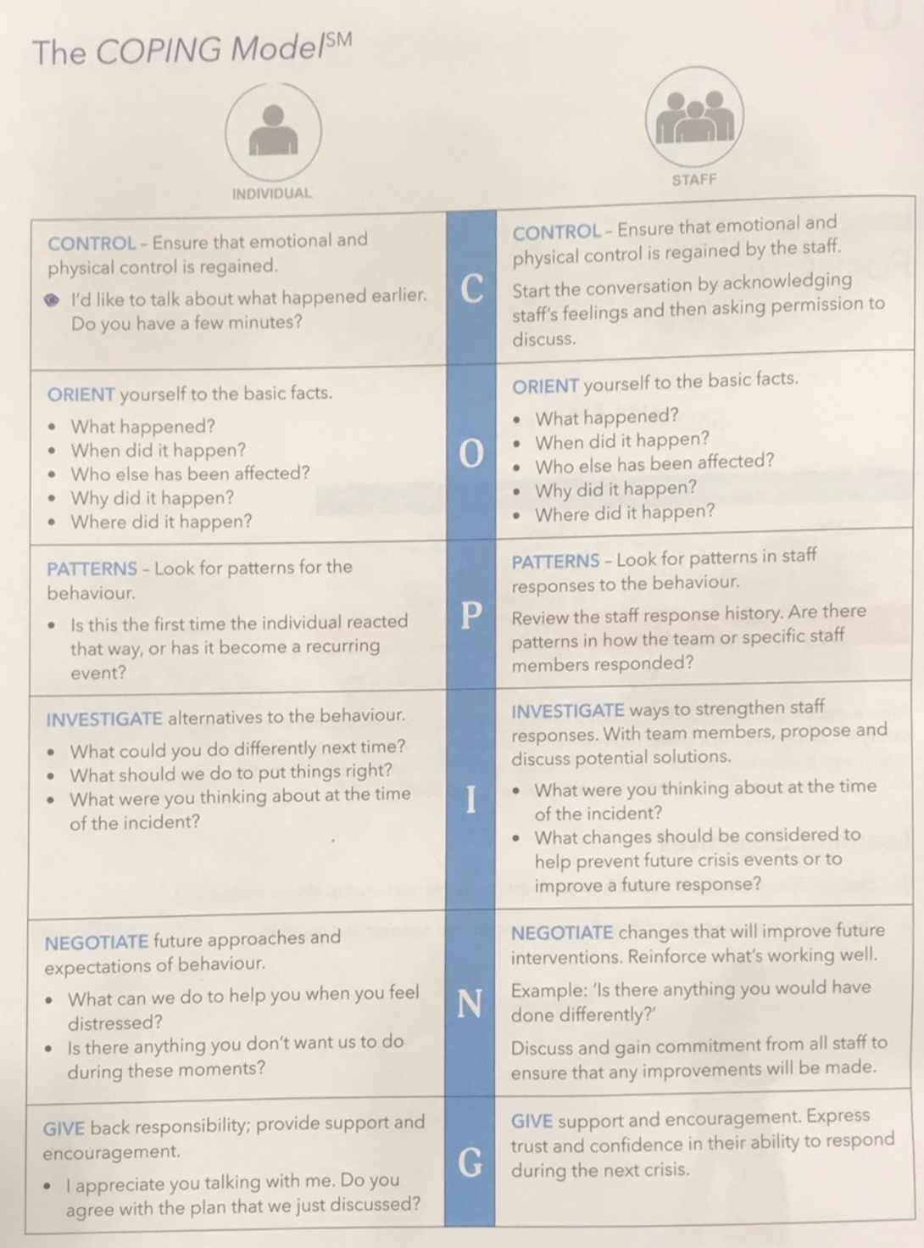

Appendix 6

The CPI Coping Model

Behaviour levels
- Anxiety - When a person is at any level of crisis, how you communicate in that moment can prevent or escalate the situation.
- Defensive – helps one to recognise behaviours at a defensive level e.g. verbal/nonverbal/questioning/ refusal
- Risk Behaviour – consider the work environment and the coordinated and collaborative approach to keep yourself and others safe when a crisis escalates to risk behaviour
- Tension Reduction – post crisis to re-establish the relationship to create a sense of calm and safety for all involved in the crisis.

Staff attitudes and Approaches
- Supportive
- Directive
- Safety Interventions
- Therapeutic Rapport

CPI Safety Intervention Terminology:

Risk Behaviour - Behaviour that presents an imminent or immediate risk.

The total loss of control, which may result in physical behaviour that presents a risk
to the person or others. At this point, physical interventions may be considered.
Examples: hitting, biting, self injury.

Tension Reduction - Decrease in physical and emotional energy.

...that occurs after any of the three previous levels of the Crisis Development Model,
characterised by the regaining of rationality.
Examples: crying, apology, reduced physical tension in the body.

Staff Responses - Supportive - An empathetic, non-judgemental approach.
Examples: listen, allow time.

Directive - Decelerating an escalating behaviour.
Examples: Clear, concise instructions, limit setting.

Safety Intervention - Disengagement and / or holding skills to
manage risk behaviour.
Examples: gaining a release from someone holding
you / you holding someone as there is an immediate or imminent risk of harm to themselves or others.

Therapeutic Rapport - Re-establish communication.
Examples: listen and demonstrate empathy, avoid blame, give reassurance.

