Literacy/ Spelling/ Phonics  Pearson Wordsmith Planning  Fiction – Myths and Legends. Features. Exploring powerful language, inference, descriptive words and phrases. Comparing legends. Saint George and the Dragon and Dragon Slayer. Exploring story through film. Heroes and beasts. Adjectives, expanded noun phrases, punctuating direct speech. Planning, drafting, writing and editing a legend.  Non Fiction – How far would I go to Look Cool? Exploring features of non-fiction. Identify and summarise main ideas. Retrieve information. Use dictionaries. Using headings, sub-headings and paragraphs to organise ideas. Drafting, writing and editing a newspaper report.  Poetry-Exploring poetic language. Read and understand the language of a poem. Syllabic poems. Comparing descriptive poems . Drafting an individual poem. | Mathematics White Rose planning  Focus on  Number: Fractions  Measurement: Money recap  Measurement:Mass and Capacity  Measurement:Time  Geometry: Properties of Shape  Addition and subtraction catch up  Mental maths rehearsing addition, subtraction, multiplication, division and fractions. | Science  Electricity  I can identify electrical and non electrical appliances  I can sort appliances based on whether they are powered by mains electricity or battery. I can explain how a circuit works. I can name three electrical conductors and insulators. I can create a simple series circuit with and without a switch. I can explain how a switch can turn an electric current on and off. I can explain why a circuit is incomplete. I can report findings and draw conclusions  Plants  I can identify the different parts of flowering plants. I can explain the function of the parts. I can identify the different parts of a flower and explain their function. I can describe the life cycle of a flowering plant  I can make observations and predict what might happen in an investigation. I can record findings and draw conclusions
Geography/History  History/ The Romans/Our Local Area  The Romans in Britain  Celtic life in Britain/our area. Looking at roundhouses and comparing to today. Boudicca. Hill forts. Expansion of the Roman Empire. Invasion of Britain in 43CE. Roman Legionnaires. Roads and towns. Roman Entertainment. Chariot Racing Circus Maximus. Why were the Romans so successful? Roman Legacy.  Geographical skills and Fieldwork  Using school environment to develop knowledge and ability to use compasses and grid references. Using maps (including Ordnance Survey) and atlases. | Around the World  Year 3  Books  Saint George and the Dragon/The Beast with a Thousand Teeth/Dragon Slayer/  Grace Nicholls Collected Poems  James Carter Collected Poems  e-book-Shocking Styles  Pippi Longstocking  The Owl who was afraid of the Dark  The Mousehole Cat  When the Whales Came | 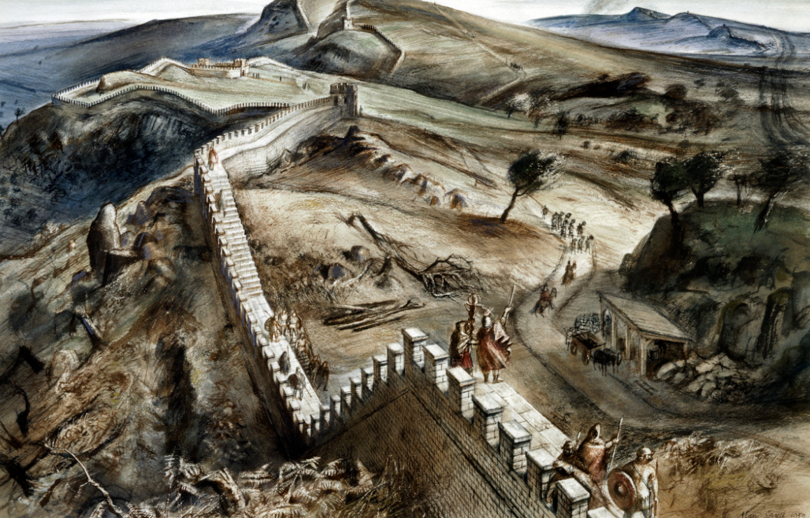  Expressive Art  ART – Roman art. Mosaics and relief panels of horses.  Making phalerae metal discs inscribed with Roman patterns and motifs using styli  Artists  Karen McDougall  Music  Mrs Hedley composition, notation, appreciation  Violin instruction  Mrs Anderson Friday 20 mins untuned/ tuned instrument and singing

